**Risk management in banking operations**

Risk management in banking operations is critical for ensuring the stability and integrity of financial institutions. Banks in the U.S. face various types of risks, including credit risk, market risk, operational risk, liquidity risk, and compliance risk. Effective risk management involves identifying, assessing, and mitigating these risks through a combination of strategies, policies, and advanced technologies. Here is an overview of risk management in banking operations in the U.S.

**Types of Risks in Banking Operations**

1. **Credit Risk**
   * **Definition**: The risk of loss due to a borrower’s failure to repay a loan or meet contractual obligations.
   * **Management Strategies**: Credit risk assessment, credit scoring models, loan diversification, collateral requirements, and credit risk mitigation techniques.
2. **Market Risk**
   * **Definition**: The risk of losses in on- and off-balance sheet positions arising from movements in market prices.
   * **Management Strategies**: Value at Risk (VaR) models, stress testing, scenario analysis, and hedging with derivatives.
3. **Operational Risk**
   * **Definition**: The risk of loss resulting from inadequate or failed internal processes, people, systems, or external events.
   * **Management Strategies**: Internal controls, process reengineering, business continuity planning, and insurance.
4. **Liquidity Risk**
   * **Definition**: The risk that a bank will not be able to meet its financial obligations as they come due.
   * **Management Strategies**: Liquidity coverage ratio (LCR), net stable funding ratio (NSFR), cash flow forecasting, and maintaining sufficient high-quality liquid assets (HQLA).
5. **Compliance Risk**
   * **Definition**: The risk of legal or regulatory sanctions, financial loss, or reputational damage due to non-compliance with laws, regulations, or internal policies.
   * **Management Strategies**: Compliance programs, regular audits, training, and regulatory monitoring.

**Key Components of Risk Management**

1. **Risk Identification and Assessment**
   * **Credit Risk Assessment**: Banks use credit scoring models and credit rating systems to assess the creditworthiness of borrowers.
   * **Market Risk Assessment**: Banks use VAR models, stress testing, and scenario analysis to assess market risk.
2. **Risk Mitigation**
   * **Credit Risk Mitigation**: Techniques include requiring collateral, credit derivatives, and loan diversification.
   * **Market Risk Mitigation**: Hedging strategies using financial derivatives such as futures, options, and swaps.
3. **Risk Monitoring and Reporting**
   * **Continuous Monitoring**: Banks use automated systems and software to continuously monitor risk exposures.
   * **Reporting**: Regular risk reports are generated for management and regulatory bodies to ensure transparency and compliance.
4. **Regulatory Compliance**
   * **Basel III Framework**: U.S. banks adhere to the Basel III regulations which include capital adequacy, stress testing, and market liquidity risk management.
   * **Dodd-Frank Act**: Requires U.S. banks to maintain rigorous risk management practices and conduct regular stress tests.

**Statistics and Examples**

1. **Credit Risk**
   * **Non-Performing Loans (NPL)**: As of Q3 2023, the average NPL ratio for U.S. banks was approximately 1.5%, reflecting effective credit risk management practices.
   * **Loan Loss Provisions**: U.S. banks' loan loss provisions amounted to $55 billion in 2023, highlighting the proactive approach to managing credit risk.
2. **Market Risk**
   * **Value at Risk (VAR)**: Large U.S. banks report an average daily VaR of around $150 million, indicating their exposure to market fluctuations.
   * **Stress Testing**: The Federal Reserve's annual stress tests show that major banks have robust capital buffers, with an average stress capital buffer of 2.5% in 2023.
3. **Operational Risk**
   * **Operational Losses**: Operational losses due to fraud, system failures, and other issues amounted to approximately $7.8 billion for U.S. banks in 2023.
   * **Cybersecurity Spending**: U.S. banks increased their cybersecurity budgets by 15% in 2023, reflecting the growing focus on managing cyber risk.
4. **Liquidity Risk**
   * **Liquidity Coverage Ratio (LCR)**: The average LCR for large U.S. banks was 130% in 2023, well above the regulatory minimum of 100%.
   * **High-Quality Liquid Assets (HQLA)**: U.S. banks hold over $3 trillion in HQLA, ensuring they can meet short-term obligations.
5. **Compliance Risk**
   * **Regulatory Fines**: In 2023, U.S. banks paid over $10 billion in fines for various compliance breaches, emphasizing the importance of stringent compliance risk management.
   * **Compliance Programs**: 90% of U.S. banks have enhanced their compliance programs in the past three years, investing in technology and training.

**Example: Bank of America**

**Credit Risk Management**

* **Loan Diversification**: Bank of America (BOA) diversifies its loan portfolio across various sectors to mitigate credit risk.
* **Credit Scoring**: BOA uses advanced credit scoring models to assess the creditworthiness of borrowers, reducing the likelihood of defaults.

**Market Risk Management**

* **VAR Models**: BOA employs sophisticated VAR models to quantify its exposure to market risks and implement appropriate hedging strategies.
* **Stress Testing**: BOA conducts regular stress tests to assess its resilience against adverse market conditions, ensuring sufficient capital buffers.

**Operational Risk Management**

* **Internal Controls**: BOA has robust internal controls and processes in place to manage operational risks effectively.
* **Cybersecurity**: The bank invests heavily in cybersecurity measures to protect against data breaches and cyber-attacks.

**Liquidity Risk Management**

* **Liquidity Coverage Ratio**: BOA maintains a high LCR, ensuring it has sufficient liquid assets to meet its short-term obligations.
* **Cash Flow Forecasting**: The bank uses advanced cash flow forecasting tools to manage its liquidity needs proactively.

**Compliance Risk Management**

* **Compliance Programs**: BOA has comprehensive compliance programs to ensure adherence to regulatory requirements and avoid legal sanctions.
* **Regulatory Monitoring**: The bank continuously monitors regulatory changes and updates its policies and procedures accordingly.

**Conclusion**

Risk management in U.S. banking operations is a multi-faceted approach that involves identifying, assessing, mitigating, and monitoring various types of risks. Banks like Bank of America employ advanced technologies and strategies to manage credit, market, operational, liquidity, and compliance risks effectively. The statistics and examples provided highlight the importance of robust risk management practices in maintaining the stability and integrity of financial institutions.

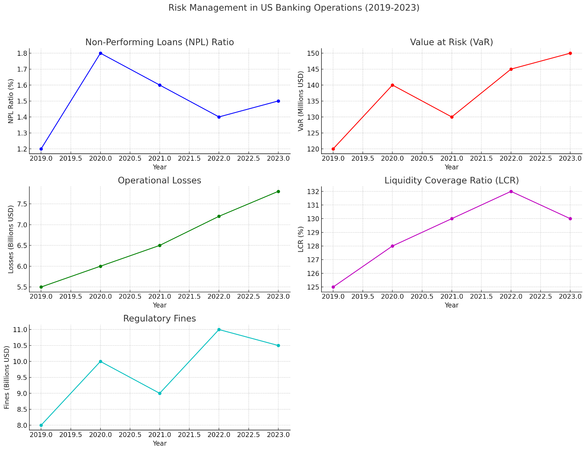

1. **Non-Performing Loans (NPL) Ratio**: This graph shows the percentage of non-performing loans relative to the total loans issued by banks. The NPL ratio increased in 2020, likely due to economic challenges from the pandemic, but showed improvement in subsequent years.
2. **Value at Risk (VAR)**: This graph represents the daily potential loss in the market value of banks' portfolios due to market fluctuations. The VAR has seen an increasing trend, indicating growing market risk exposures that banks need to manage.
3. **Operational Losses**: This graph illustrates the total operational losses incurred by banks due to factors such as fraud and system failures. There is a noticeable upward trend, highlighting the increasing importance of robust operational risk management practices.
4. **Liquidity Coverage Ratio (LCR)**: This graph shows the average LCR of U.S. banks, which measures their ability to meet short-term obligations. The LCR has remained above the regulatory minimum of 100%, demonstrating strong liquidity risk management.
5. **Regulatory Fines**: This graph represents the total fines paid by U.S. banks for regulatory breaches. While there was a spike in fines in 2022, the trend indicates that banks continue to face significant compliance risks that need effective management.